

|  |
| --- |
| Apparel & Footwear |
| **ATP and Allocation** |
| Argentis Consulting p 10 |



**www.argentisconsulting.com**

# ATP

The following steps describes the Available to Promise process

**Previous Settings**

1. Warehouse handling time (in days). Time that should be added as a lead time when calculating planned delivery date when running ATP.

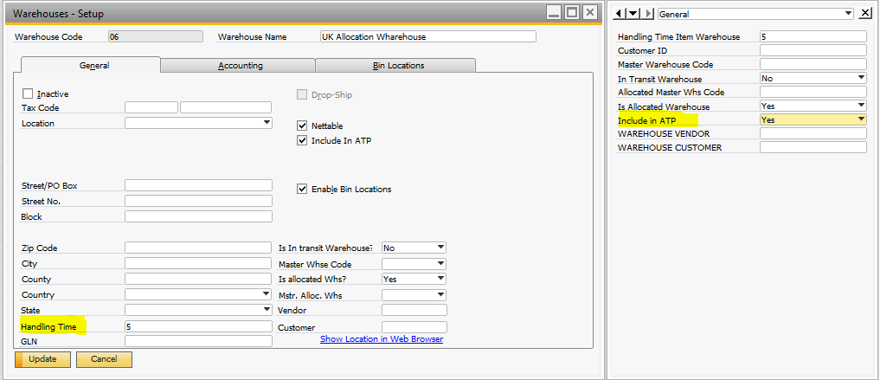

1. Default customer ship to. Shipping time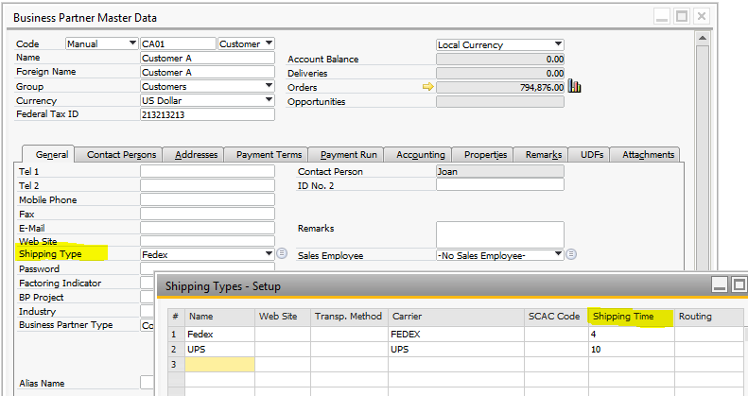

**Procedure**

Available-to-promise (ATP) is a business function that provides a response to customer order enquiries, based on resource availability.

Example, this Style has no stock or availability

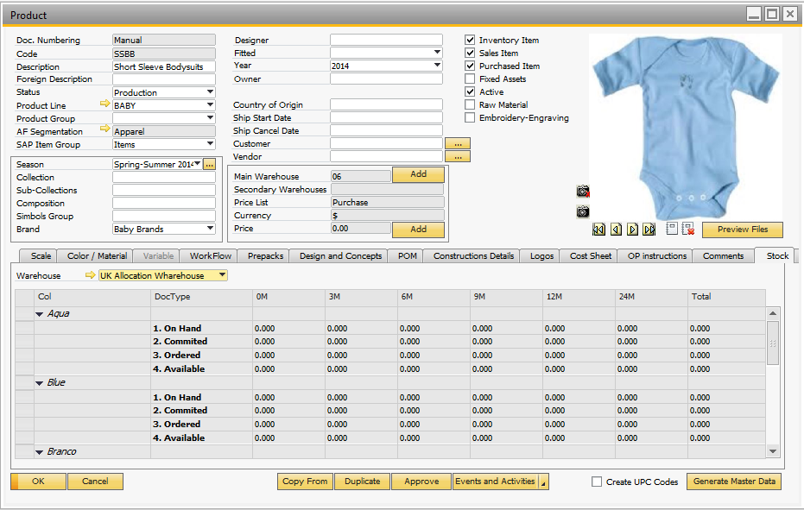

Then, when the user places a new Sales Order, should be completed a Requested Delivery date and the quantities by color-size.

With the option “View ATP report, overall details” we will visualize the ATP quantities for the specific due date.

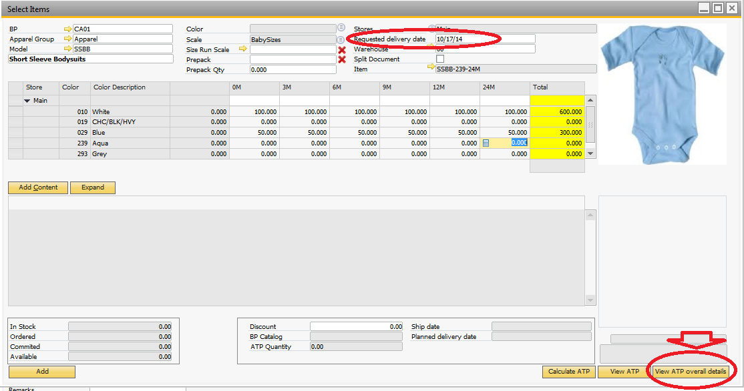

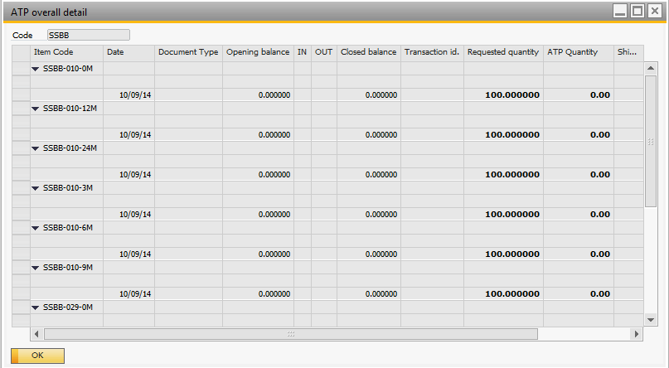

Nothing is planned as incoming (purchasing or production) or outgoing (sales orders)

If a Purchase Order is placed against the style

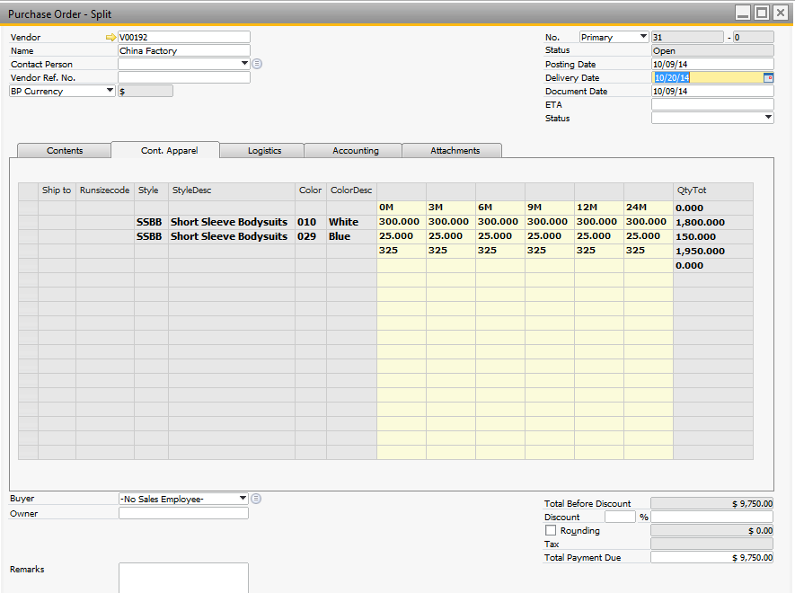

When running the ATP it is displayed as an incoming transaction.

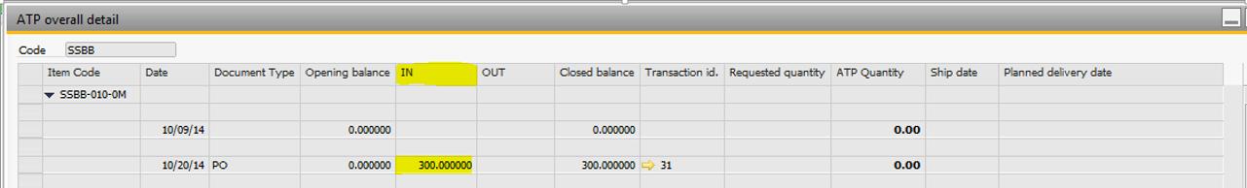

If a new Sales Order is created, we will visualize the ATP quantity and the planned delivery date according the Purchase orders and sales orders existing for the item.

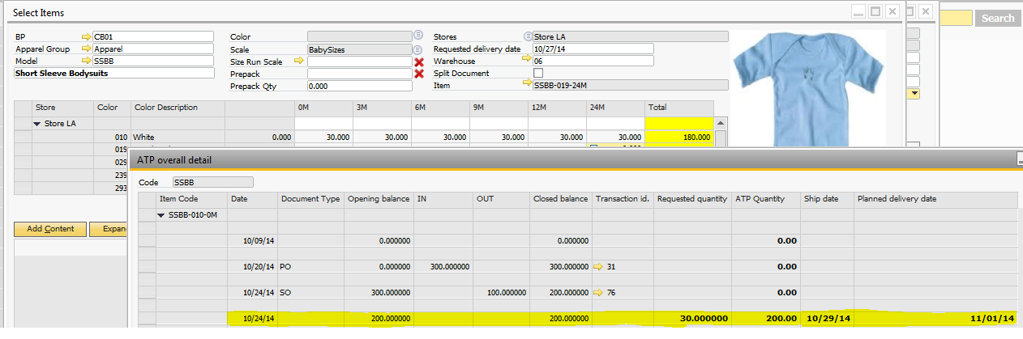

The user can promise the 30 units to the customer as the ATP quantity is 200, with a Planned Delivery date of the SO in 11/01/2014.  
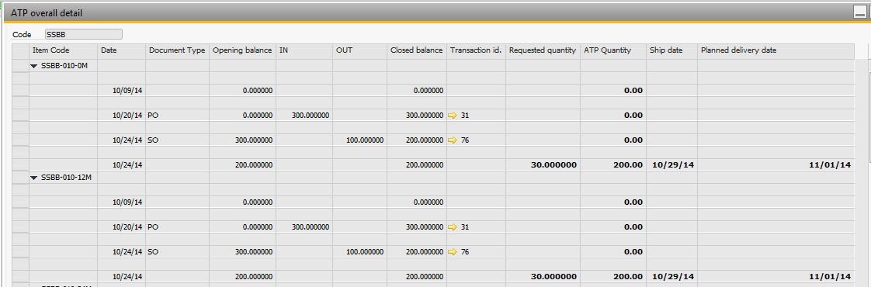

Planned delivery date is calculated based on the customer shipping type and handling time in the warehouse.

There is a Report in the Style: ATP Report. That allows to check the ATP visualizing the matrix color-sizes.

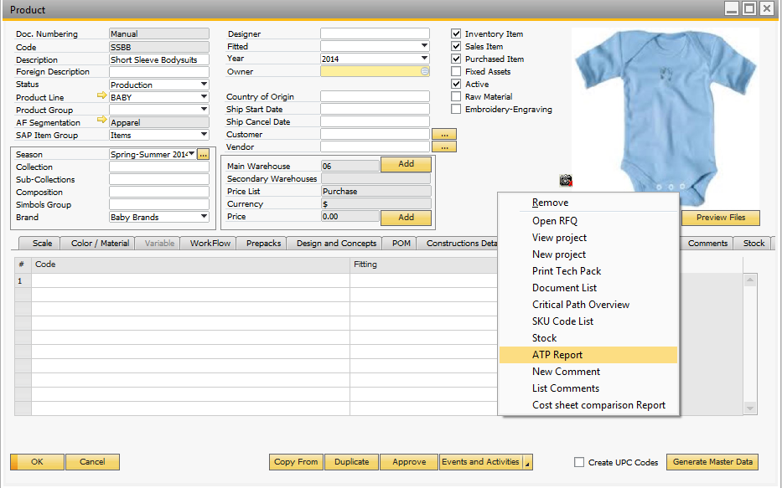

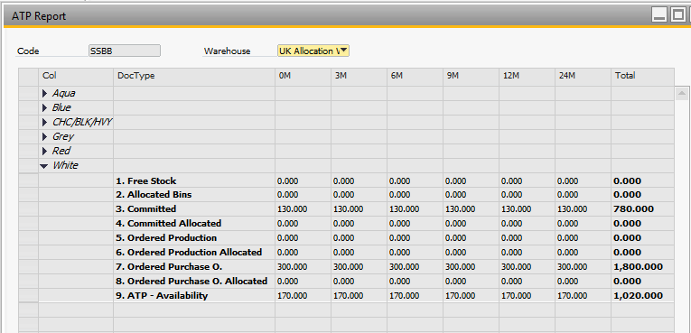

## Release 2.2.26-27

### Style ATP Screen Report

Now the user can quickly review the style ATP information by color – size

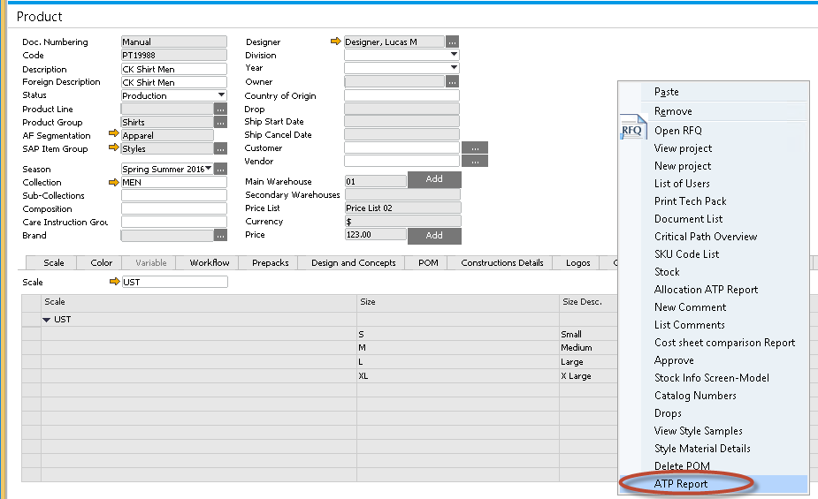

The report calculates the projected quantity available for an item in a business unit on a given date, enabling you to promise orders against future supply

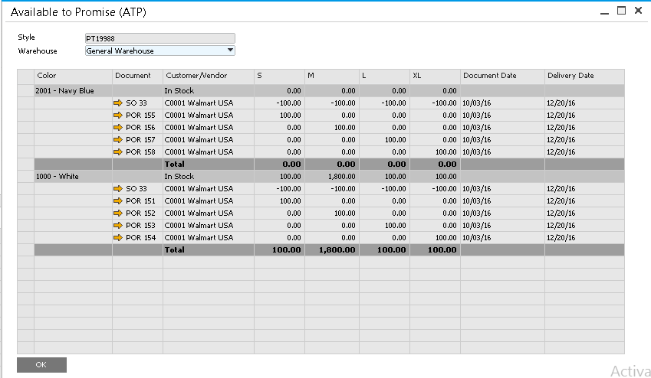

# Allocation

## Allocation processes

***1. Stock***

The process of allocating inventory to sales orders reserves stocked products for that customer, this prevents them from being sold to someone else. Until inventory is allocated, the on hand inventory level will not be reduced and the inventory could potentially be allocated to another sale, leaving no inventory to fulfil this order. Allocating stock to sales means it is removed from the on-hand stock in the main warehouse or distribution center value and cannot be sold to anyone else, unless unallocated from the sales order. When there is not enough stock to fulfil a whole order the status will show you that there are items left outstanding.

***2. WIP (Production or Purchase Orders)***

Similar to stock, allocating WIP orders to sales orders reserves stocked products for that customer, preventing them from being sold to someone else. When receiving the goods, the stock is placed in a different or particular bin in the warehouse to run the final stock allocation.

## Setup

In order to propose and automate the allocation run the user must setup:

* *Customer Priority.* Create the different priorities in the order needed to run the allocation. Customer with highest priorities will be served first. The following values will be created for customer priority:

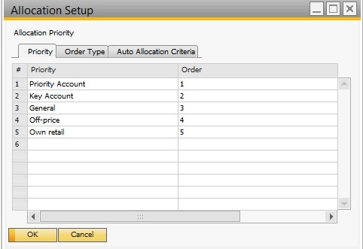

* *Order Type.* The user must create at least 1 order type value to assign to all orders. Then the value is linked to the sales order. If not the default value is assigned.

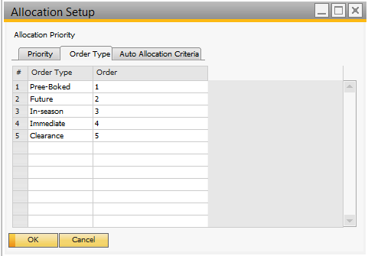

* *Allocation Priority Setup.* Enter in the table the order the process will run during allocation. The options are: Priority, Order Type, Delivery Date or Document Date.

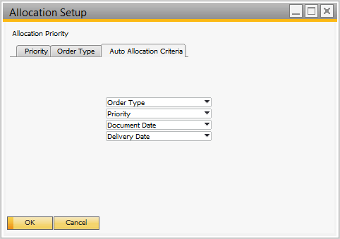

* *Setup customer bins or warehouses:* Create allocation warehouses or bins

Create at least 1 warehouse to allocate final stock to customers. In order to split the stock based on customer importance or priority create the necessary bins. Example Flyers: Duty Paid, Bonded and Allocated. Remember to configure the Bin of allocation to be able to Hard allocation.

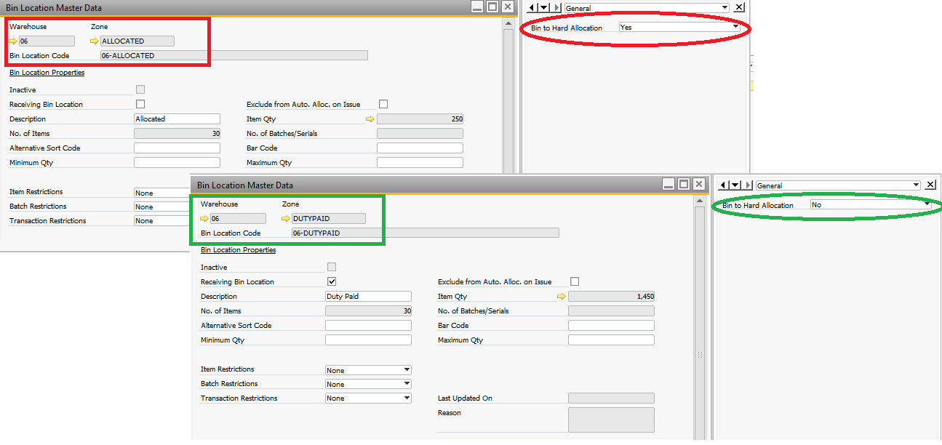

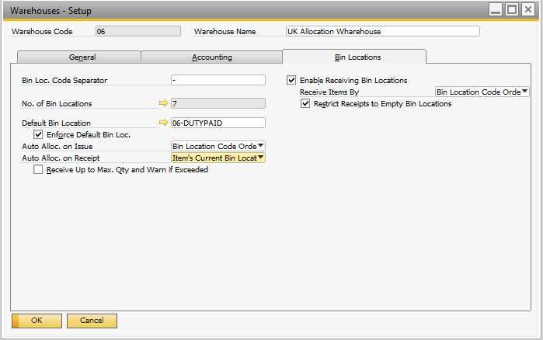

* *Link the warehouses / bins the customer master record.*

Select if the customer is managed for allocation process automatically. Also specify allocation priority, warehouse and Bin Locations where the final allocation will be stored.

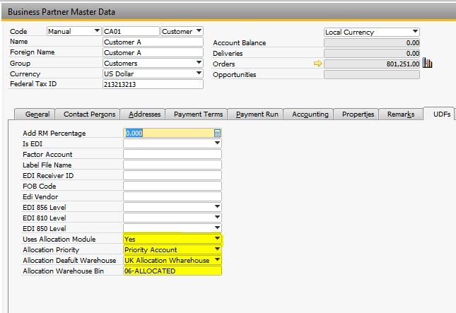

* *Link the warehouses / bins the style master record:* Select the Warehouse and Bin to the Style

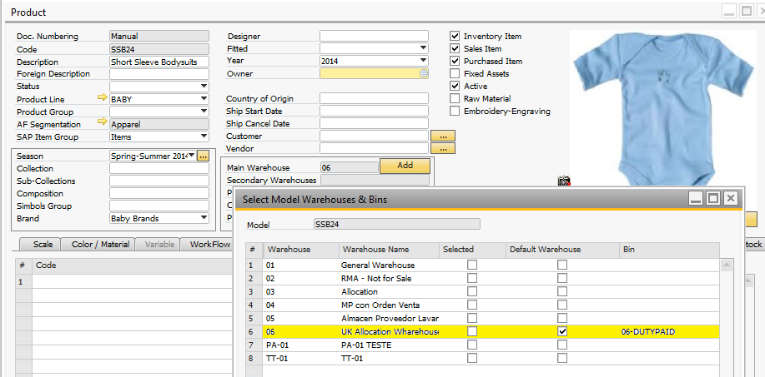

## Allocation Types

### Batch Allocation: Allocating on hand stock to open sales orders in batch

This wizard shows all styles in stock on the selected warehouse as Source. At the bottom all open sales orders with free quantities.

In the Menu, option: Apparel and Footwear 🡪 Sales 🡪 Allocation 🡪 Allocation Wizard stock

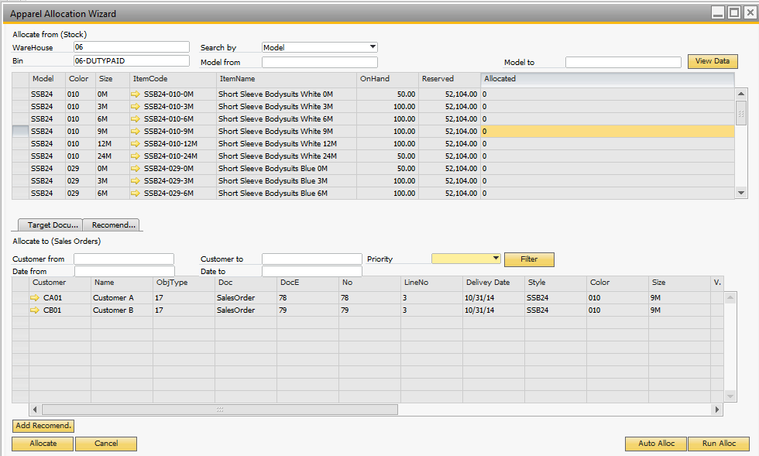

Allocation against stock is done against on hand stock by warehouse and Bin. Usually the stock is stored in a main warehouse. When entering orders, they can be reserved and transferred to a customer bin or warehouse.

Select option “Run Allocation” the process will “Recommend” based on the priority system setup by the user (1- customer 2- order type 3- delivery date, or a different order).

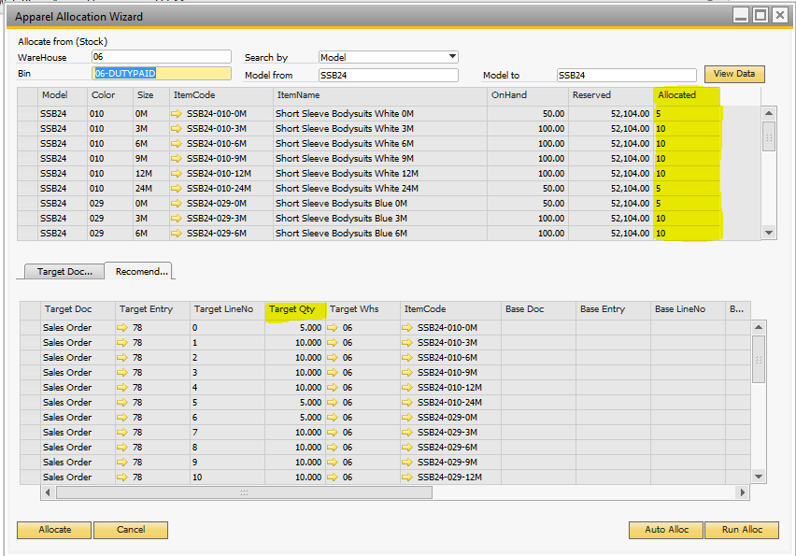

Once the process is done an allocation entry is created reserving the items to the customer bin or warehouse.

Select the option “Allocate” to save the Recommendation.

### Manual Allocation - Allocation individual SKUs to open orders or stock

The user can select individual styles – colors – sizes – variants and send to the recommendation window. The allocation is done Item per Item.

Select the option “Auto Allocation”

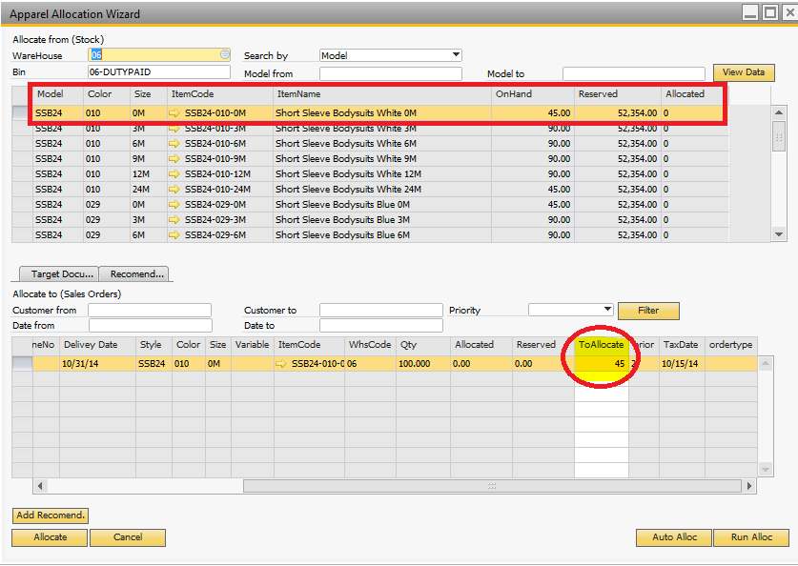

In this example it´s a partial allocation, because the On Hand Stock is less than the qty of the Sales Order.

The Wizard completes the qty available to be allocated. To Allocate that partial quantity, select the option “Add Reccomendation”.

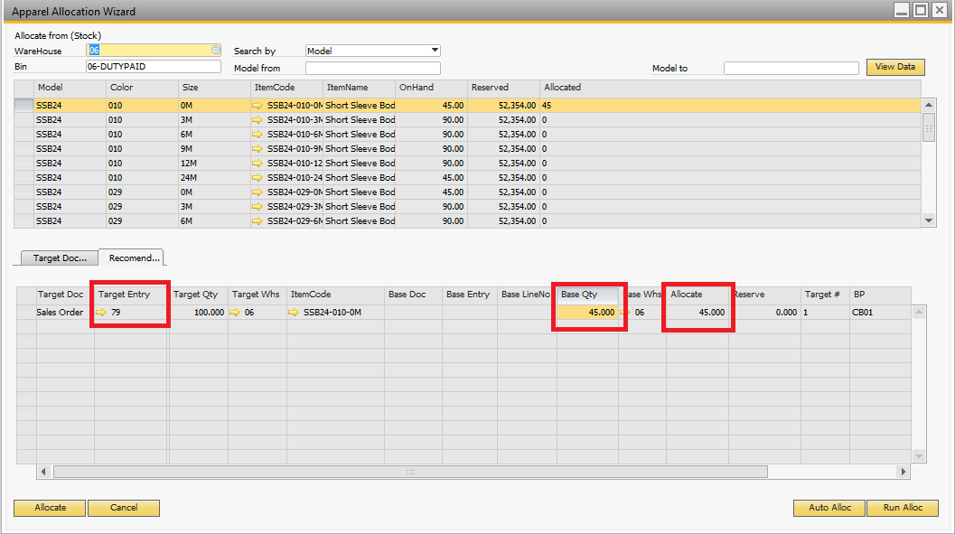

To save the allocation select the option: “Allocate”.

### Stock Allocation: trigger allocation process automatically

In order to run the allocation process automatically the solution supports the option to allocate and run the allocation process automatically. This is configured in the setup and during runtime process.

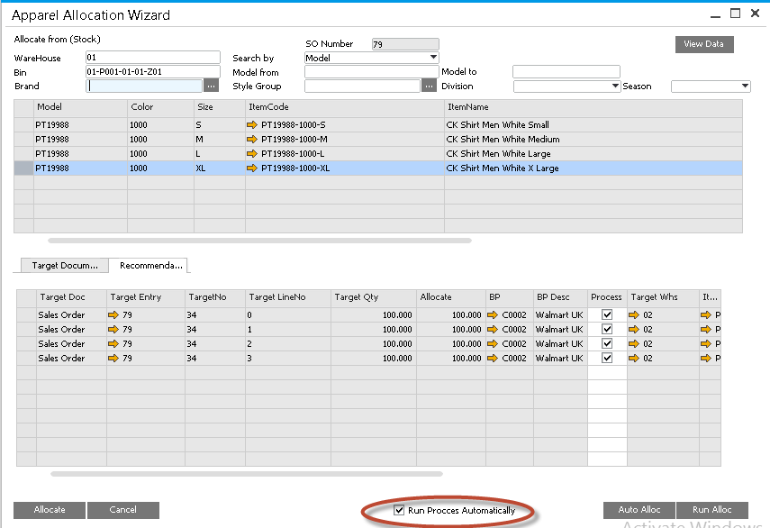

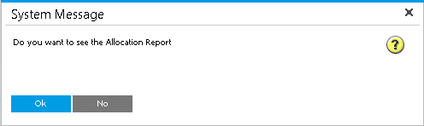

### Allocating orders in WIP to sales orders

Allocate by sweeping purchase or manufacturing orders to all open sales orders using the priority system. The system must recommend based on the priority setup (sort by customer, order type, delivery date)

In the Menu, option: Apparel and Footwear 🡪 Sales 🡪 Allocation 🡪 Allocation Wizard

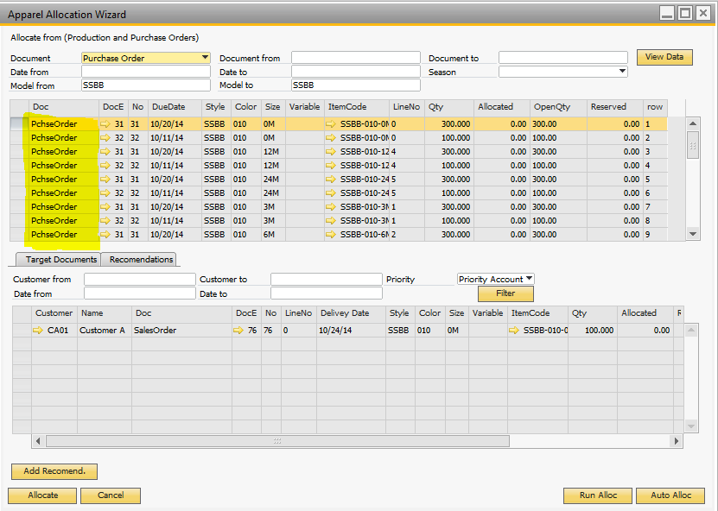

Deallocate inventory to free it up for another sales orders

Access the allocated quantities from the sales order / Purchase Order. Right click in the document – option “View allocation data”. It also helps to deallocate quantities.

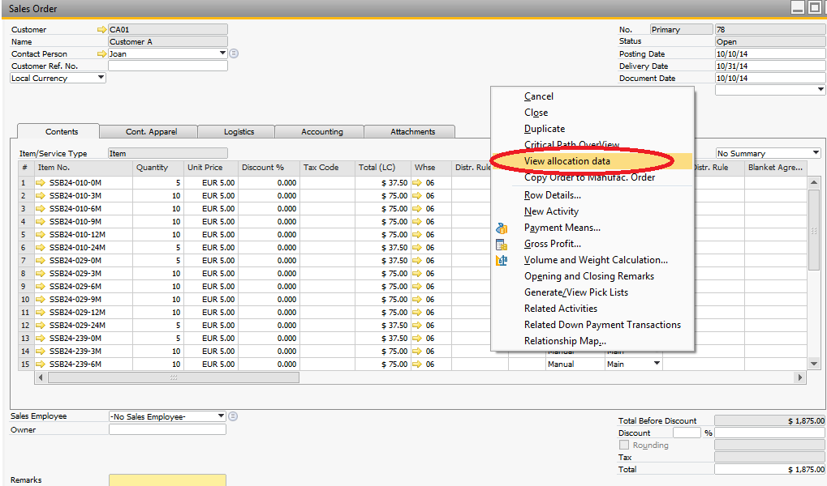

The deallocation process will remove the allocated quantities from the order and reverse the inventory transaction created during allocation run.

In order to deallocate the user will have to open the order or allocation entry. Select the lines and quantities to de allocate and click on the update button.

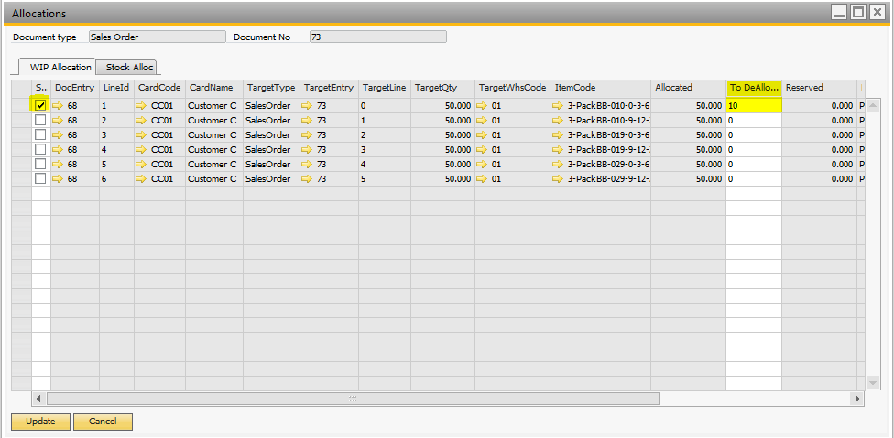

To visualize the Inventory Transfer detail, when the allocation was generated from on hand inventory. Go to: Apparel and Footwear 🡪 Sales 🡪 Allocation 🡪 Allocation Transfer UDO.

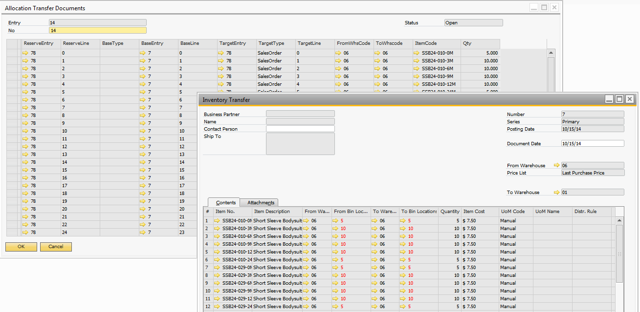

To visualize the allocation documents generated when it´s generated from production order or purchase order. Go to: Apparel and Footwear 🡪 Sales 🡪 Allocation 🡪 Allocation UDO.

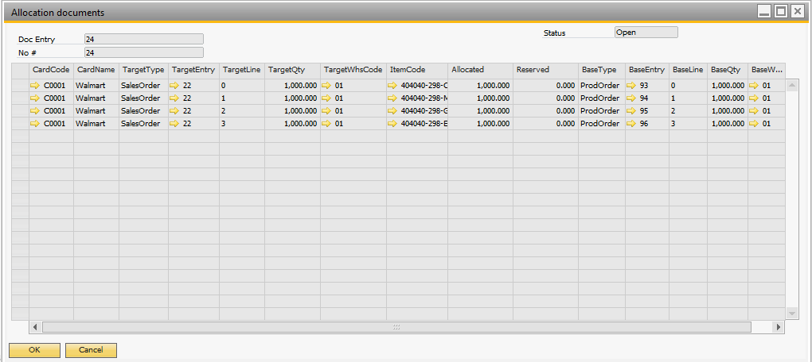

Also, in the Style, in the ATP Report can visualize the total quantity in free stock and the allocated qty.

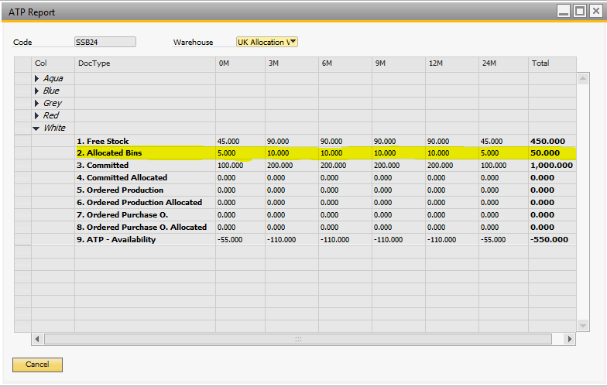

## Allocation: runtime report

A new allocation report has been added to the solution. The user enter the report parameters and access the information with drill down capabilities.

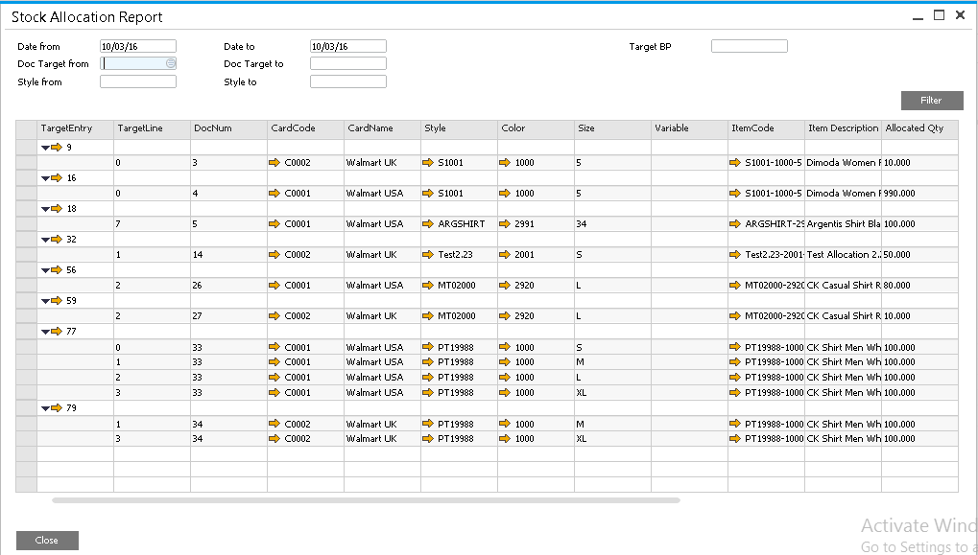

## Allocation new features and fixes

### Performance enhancement when allocating orders

Release 2.2.13

In order to get better performance when allocating orders assign a default value of 0 to the following UDFs at order line level: AllocatedQty, ReservedQty, FreeQty, CutQty, FreeQtyToCopy. These fields also need to be set to this value to avoid errors when duplicating orders.

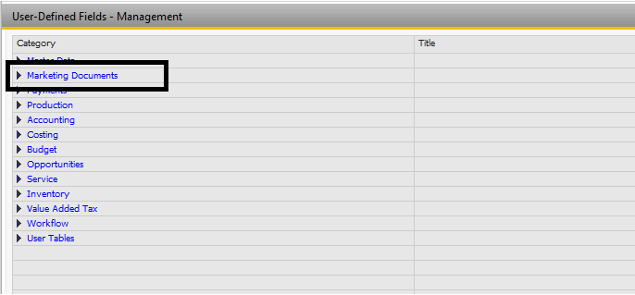

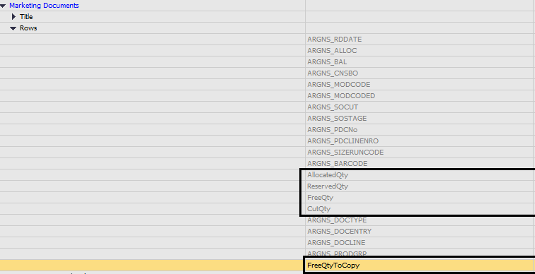

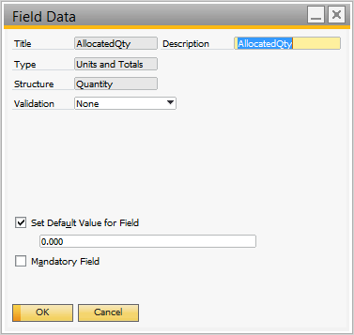

Once all changes have been made, you must close SAP and login again so changes take effect.

### View Allocation Data on Sales Order

Allocation information at line level (Allocated, Reserved, Free Stock) has been removed from the documents to improve performance. To check the allocation information on orders right click and select View Allocation Data.

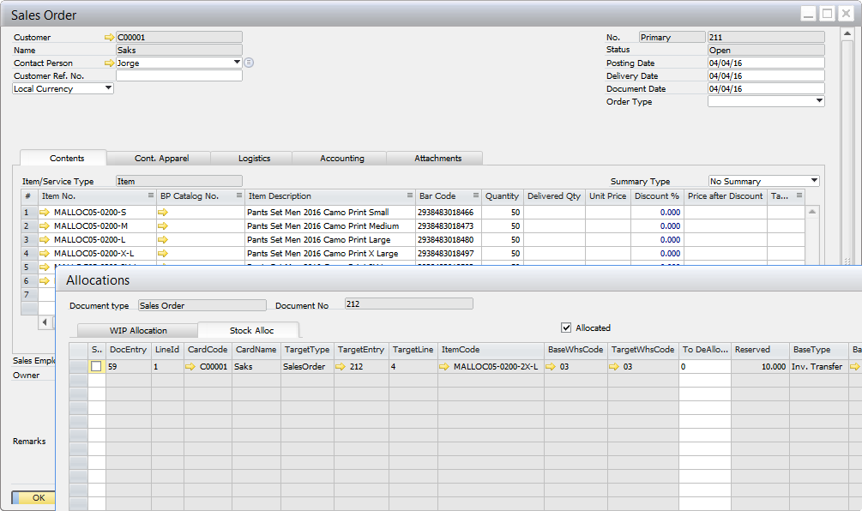

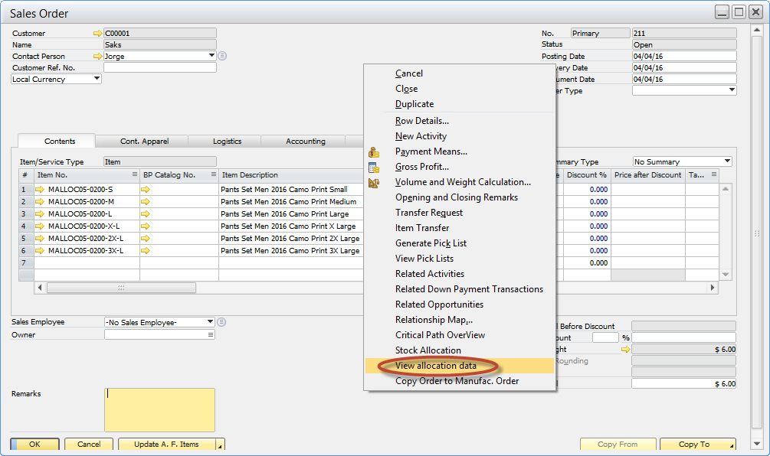

### View Allocation Data

### If the order has been de-allocated and allocated again a new check has been added to show only allocated lines.

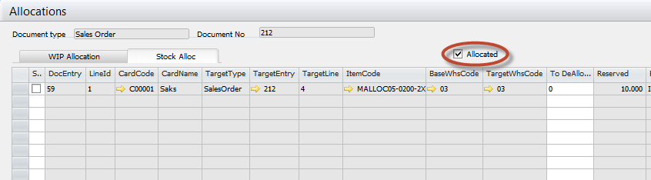

### Order Allocation – New controls

#### The user cannot de-allocate partial – delivery quantities

If the order quantities are partially or fully allocated the order lines cannot be deallocated.

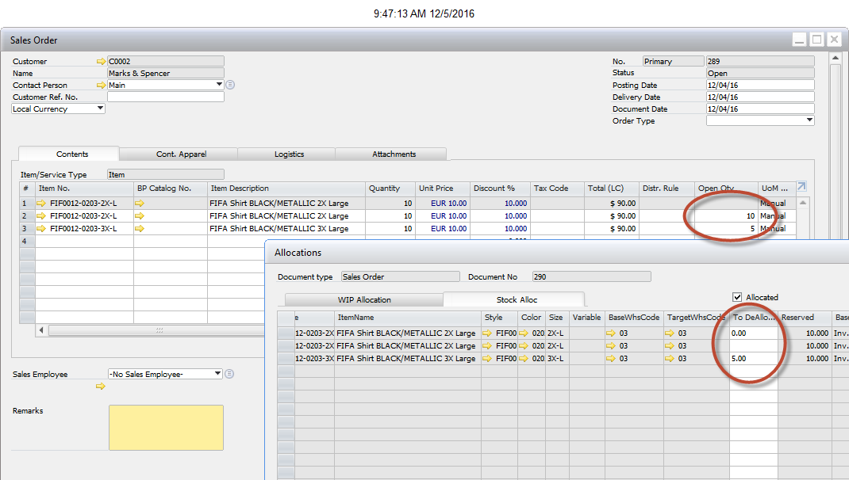

#### New filter to only allocate approved orders

Usually only approved orders can be allocated. Now there is a new setting to filter only approved orders in the allocation run wizard?

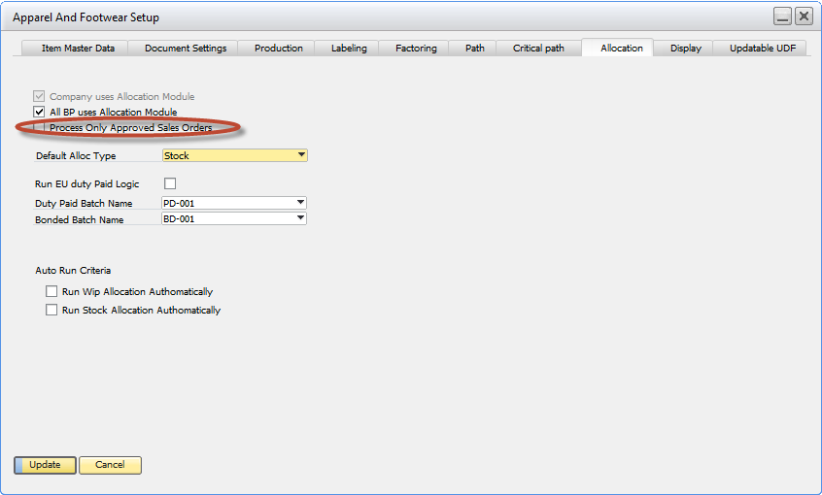

#### New Store procedure avoid user to edit an order / order lines when it is allocated

In order to avoid user to edit, close, cancel lines that are allocated, even if the AFS solution is not running, code needs to be updated in order to block these taks. THIS IS MANDATOY FOR ALL CUSTOMERS RUNNING THE ALLOCATION WIZARD

Add this code to the transaction notification store procedure in SAP (SQL)

ALTER proc [dbo].[SBO_SP_TransactionNotification]

@object_type nvarchar(20), -- SBO Object Type

@transaction_type nchar(1), -- [A]dd, [U]pdate, [D]elete, [C]ancel, C[L]ose

@num_of_cols_in_key int,

@list_of_key_cols_tab_del nvarchar(255),

@list_of_cols_val_tab_del nvarchar(255)

AS

begin

-- Return values

declare @error int -- Result (0 for no error)

declare @error_message nvarchar (200) -- Error string to be displayed

select @error = 0

select @error_message = N'Ok'

--------------------------------------------------------------------------------------------------------------------------------

-- ADD YOUR CODE HERE

--agregar control de que la orden exista en alguna linea de alloc, soft y hard.

IF (@object_type = '17') and (@transaction_type IN ('U', 'C'))

BEGIN

IF (select Count(*) as 'cant' from "@ARGNS_ALLOCTL" where U_ReserveType = 17 and U_ReserveEntry = @list_of_cols_val_tab_del and U_Qty > 0

) > 0

or (select Count(*) as 'cant' from "@ARGNS_ALLOCL" where U_TargetType = 17 and U_TargetEntry = @list_of_cols_val_tab_del and U_ReservedQty > 0

) > 0

BEGIN

---- cant not chage lines, add or delete is forbbiden

if (select count(*) as cant from ADO1 where ObjType = 17 and DocEntry = @list_of_cols_val_tab_del

and loginstanc = (select max(loginstanc) from ADO1

where ObjType = 17

and DocEntry = @list_of_cols_val_tab_del )) <>

(select count(*) as cant from RDR1 where ObjType = 17 and DocEntry = @list_of_cols_val_tab_del )

Select @error = 10, @error_message = 'Sales Order Lines Cannot be modified because it is already allocated.'

else

-- cant not chage item Code

if (select count(*) from RDR1 A, ADO1 B

where A.DocEntry = B.DocEntry

and A.LineNum = B.LineNum

and A.ItemCode <> B.ItemCode

and B.loginstanc = (select max(loginstanc) from ADO1 C where C.DocEntry = B.DocEntry )

and A.DocEntry = @list_of_cols_val_tab_del

) > 0

OR

-- cant not chage item qty

(select count(*) from RDR1 A, ADO1 B

where A.DocEntry = B.DocEntry

and A.LineNum = B.LineNum

and A.Quantity <> B.Quantity

and B.loginstanc = (select max(loginstanc) from ADO1 C where C.DocEntry = B.DocEntry )

and A.DocEntry = @list_of_cols_val_tab_del

) > 0

OR

-- cant not chage line status

(select count(*) from RDR1 A, ADO1 B

where A.DocEntry = B.DocEntry

and A.LineNum = B.LineNum

and A.LineStatus <> B.LineStatus

and B.loginstanc = (select max(loginstanc) from ADO1 C where C.DocEntry = B.DocEntry )

and A.DocEntry = @list_of_cols_val_tab_del

) > 0

Select @error = 20, @error_message = 'Sales Order Item Code, Item Quanty or Status in Order lines, cannot be modified because it is already allocated.'

END

END

--------------------------------------------------------------------------------------------------------------------------------

-- Select the return values

select @error, @error_message

end

Add this code to the transaction notification store procedure in SAP (HANA)

--drop PROCEDURE SBO_SP_TransactionNotification

CREATE PROCEDURE SBO_SP_TransactionNotification

(

in object_type nvarchar(30), -- SBO Object Type

in transaction_type nchar(1), -- [A]dd, [U]pdate, [D]elete, [C]ancel, C[L]ose

in num_of_cols_in_key int,

in list_of_key_cols_tab_del nvarchar(255),

in list_of_cols_val_tab_del nvarchar(255)

)

LANGUAGE SQLSCRIPT

AS

-- Return values

li_qtyintableWip int;

li_qtyintableStock int;

li_qtyinOrder int;

li_qtyinlog int;

li_temp int;

error int;

error_message nvarchar (200);

BEGIN

error:=0;

error_message:=N'Okrr';

li_qtyintableWip:=0;

li_qtyintableWip :=0;

IF object_type = '17' AND (transaction_type = 'U' OR transaction_type = 'C' OR transaction_type = 'D' ) THEN

--select 'ACA', 'LLEGO' FROM dummy;

SELECT COUNT(*) INTO li_qtyintableWip

FROM "@ARGNS_ALLOCL"

WHERE "U_TargetType" = '17' AND "U_AllocatedQty" > 0

AND "U_TargetEntry" = list_of_cols_val_tab_del;

SELECT COUNT(*) INTO li_qtyintableStock

FROM "@ARGNS_ALLOCTL"

WHERE "U_ReserveType" = '17' AND "U_Qty" > 0

AND "U_ReserveEntry" = list_of_cols_val_tab_del;

IF (li_qtyintableStock > 0) OR (li_qtyintableWip > 0) THEN

SELECT MAX("LogInstanc") INTO li_temp FROM "ADO1"

WHERE "ObjType" = '17'

AND "DocEntry" = list_of_cols_val_tab_del ;

SELECT COUNT(*) INTO li_qtyinlog

FROM "ADO1"

WHERE "ObjType" = '17'

AND "DocEntry" = list_of_cols_val_tab_del

AND "LogInstanc" = li_temp;

SELECT COUNT(*) INTO li_qtyinOrder

FROM "RDR1"

WHERE "ObjType" = '17' AND "DocEntry" = list_of_cols_val_tab_del;

IF li_qtyintableStock <> li_qtyinlog THEN

error := 20;

error_message :=N'Sales Order Lines Cannot be modified because it is already allocated.';

else

li_temp := 0;

-- cant not chage item Code

SELECT COUNT(*) INTO li_temp

FROM "RDR1" A, "ADO1" B

WHERE A."DocEntry" = B."DocEntry"

AND A."LineNum" = B."LineNum"

AND A."ItemCode" <> B."ItemCode"

AND B."LogInstanc" = (SELECT MAX("LogInstanc") FROM "ADO1" C WHERE C."DocEntry" = B."DocEntry")

AND A."DocEntry" = list_of_cols_val_tab_del;

-- cant not chage item qty

SELECT COUNT(*) INTO li_temp

FROM "RDR1" A, "ADO1" B

WHERE A."DocEntry" = B."DocEntry"

AND A."LineNum" = B."LineNum"

AND A."Quantity" <> B."Quantity"

AND B."LogInstanc" = (SELECT MAX("LogInstanc") FROM "ADO1" C WHERE C."DocEntry" = B."DocEntry" )

AND A."DocEntry" = list_of_cols_val_tab_del;

-- cant not chage line status

SELECT COUNT(*) INTO li_temp

FROM "RDR1" A, "ADO1" B

WHERE A."DocEntry" = B."DocEntry"

AND A."LineNum" = B."LineNum"

AND A."LineStatus" <> B."LineStatus"

AND B."LogInstanc" = (SELECT MAX("LogInstanc") FROM "ADO1" C WHERE C."DocEntry" = B."DocEntry")

AND A."DocEntry" = list_of_cols_val_tab_del;

IF li_temp > 0 THEN

error := 30;

error_message :=N'Sales Order Item Code, Item Quantity or Status in Order lines, cannot be modified because it is already allocated.';

END IF;

END IF;

END IF;

END IF;

-- Select the return values

select :error, :error_message FROM dummy;

END;

NOTE: Request the original files to support, sometimes copying the text to the editor may cause errors.



**www.argentisconsulting.com**

|  |  |
| --- | --- |
| **USA**  9744 NW 45th Lane  Doral, FL 33178  info@argentisconsulting.com | **ARGENTINA**  Ávila y Zarate 2048  Cerro de la Rosas, Córdoba,  CP 5009  Córdoba - Argentina  info@argentisconsulting.com |
| **CARIBEAN**  City View Plaza – Suite 301  48 Road 165  Guaynabo, PR. 00968  Puerto Rico  caribe@argentisconsulting.com | **SPAIN**  C/ Juan Bravo N° 3 A 28006  Phone: (+34) 91 123 7263  Madrid - Spain  info@argentisconsulting.com |

**INFORMACIÓN DE CONTACTO**

**Argentis Consulting** is dedicated to the development, distribution   
and support of recognized certified solutions for SAP Business One.   
As an SAP Software Service Provider Partner with Gold Status.